Experiment no :- 7

Aim :- Visualization of Data using Pivot Table and Pivot Chart.

Step 1:-

First go to insert and select pivot table and after that select the fields you want in your pivot table

Step 2 :-

After making the pivot table go to insert and insert pivot chart.

Step 3:-

1. Find out how many items (all items) were sold in the Middle East and North Africa Region

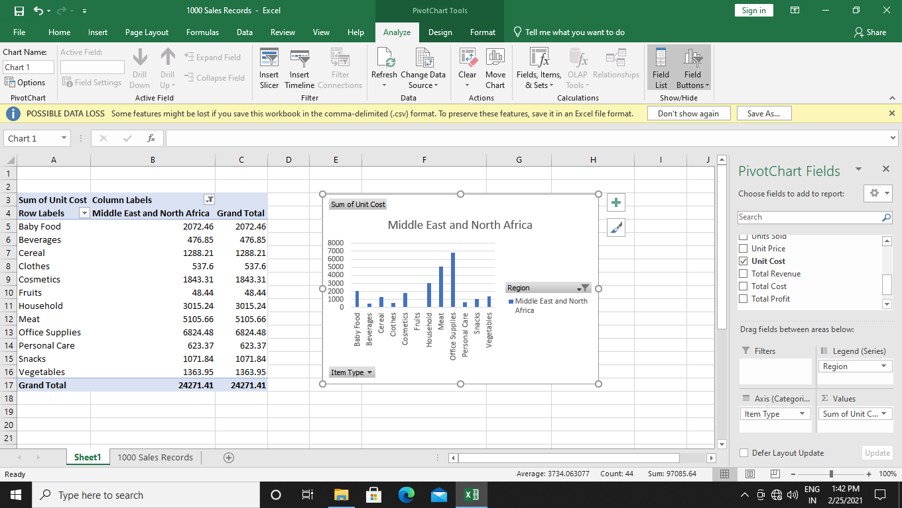

1. List the items that got sold according to the region and country

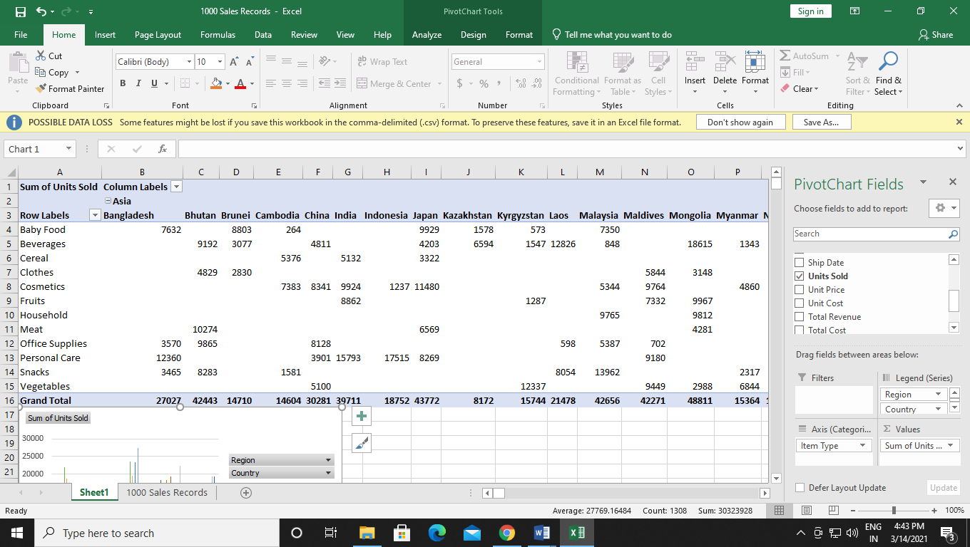

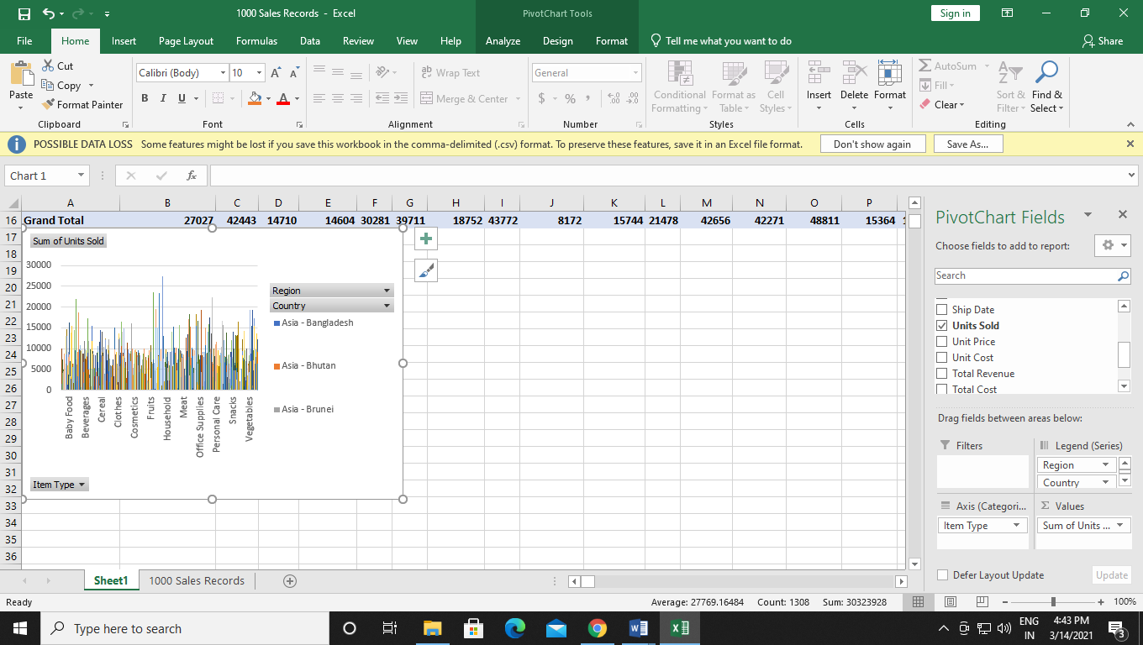

1. List the Sales channel of the individual items.

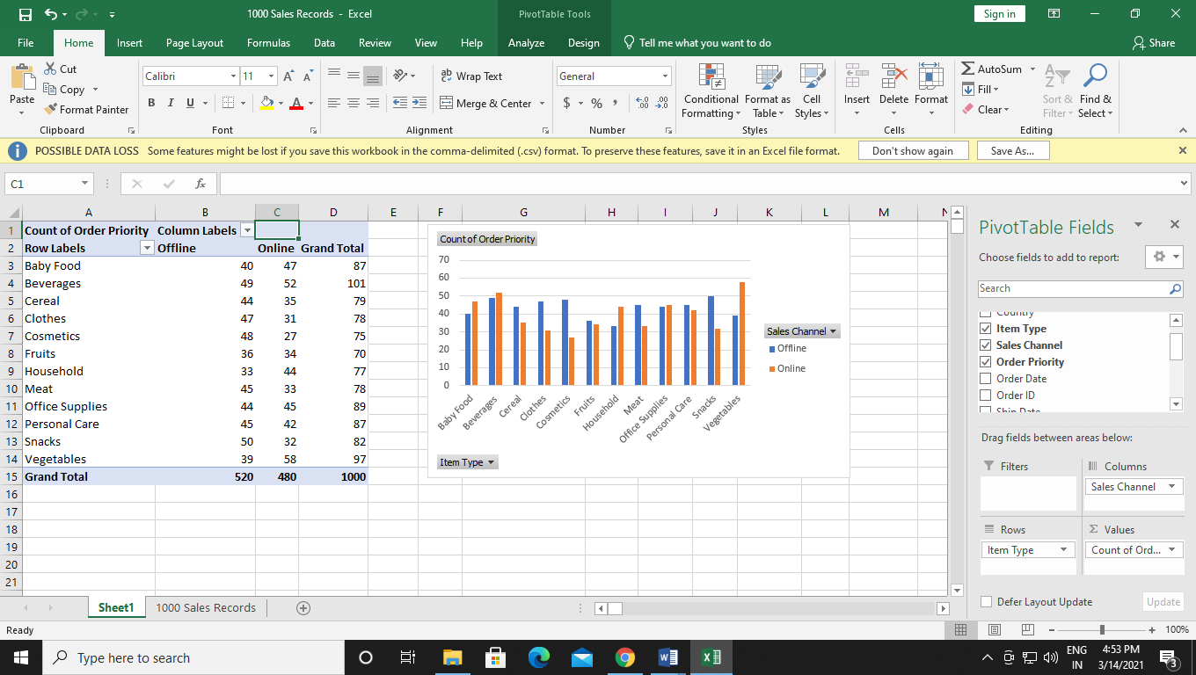

1. Find the priority level of the items.

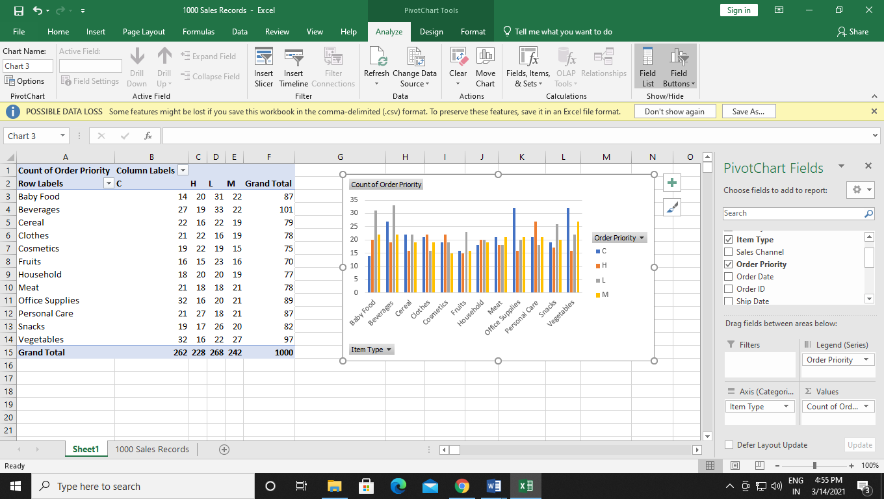

1. Which is the most profitable country in terms of revenue generation.

